7.15: Of the many ways to find energy in a spring in terms of the force and the distance, one way (which avoids the intermediate calculation of the spring constant) is to note that the energy is the product of the average force and the distance compressed or extended. a) 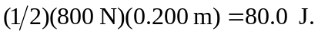 b) The potential energy is proportional to the square of the compression or extension; 

